

INDIAN INSTITUE OF SCIENCE EDUCATION AND RESEARCH TIRUPATI

MASTERS OF SCIENCE – DATA SCIENCE AND ARTIFICAL INTELLIGENCE

PROJECT WORK – FINAL SEMESTER

DEMAND PATTERN-BASED WEEKLY SALES FORECASTING FOR TRAIL EDGE PRODUCTS

KARAN. S
20254018

TABLE OF CONTENTS
S.NO | CONTENTS | PAGE NO
1 | MOTIVATION FOR THE WORK | 3
2 | CURRENT PROGRESS MADE | 3
3 | FUTURE PROGRESS | 4
4 | ANNEXURE | 5

Motivation for the Work:
Demand forecasting is very important in retail because product demand does not behave the same way for all items. Some products sell regularly, while others have irregular or seasonal demand. Because of this, using a single forecasting method for all products may not give good results. This project is motivated by the need to build a more practical forecasting system for Trail Edge products by first understanding product demand patterns and then selecting suitable forecasting methods. The work combines data analysis, demand classification, and model tuning to create a more meaningful business-oriented forecasting approach.

Current Progress Made:
The work completed so far has mainly focused on understanding the problem properly and planning the forecasting pipeline in a structured way before directly moving into model building. The project is aimed at forecasting product-level weekly sales demand for Trail Edge products and later presenting the forecasted results at a monthly level for easier business interpretation. One important decision made in the beginning was that the same forecasting logic should not be applied to all products, because not all products follow the same sales pattern.
At this stage, the two main datasets required for the project have been identified and understood. The first dataset is Product Information, which contains product-related attributes such as category, sub-category, gender, launch details, and price-related information. The second dataset is Weekly Sales, which contains product-level sales performance over time. These two datasets together form the core base for the forecasting system.
So far, the project structure has been clearly planned up to the model validation stage. This includes data preprocessing, exploratory data analysis, merging the datasets, demand pattern classification, internal feature engineering, model selection, hyperparameter tuning, and time series cross-validation. Separate preprocessing steps have been planned for both datasets so that data cleaning and understanding can be done properly before merging them.
A key part of the current progress is the finalized analytical strategy for demand classification. Products will be classified into four demand types: Smooth, Erratic, Intermittent, and Lumpy. This classification will be done using standard demand pattern metrics such as Average Demand Interval (ADI) and Squared Coefficient of Variation (CV²). This is an important part of the project because it helps identify which products are stable and which are more difficult to forecast. It also makes the forecasting process more practical and closer to real-world demand planning.
In addition to this, the exploratory analysis structure after merging has also been planned. The project will study product performance across category, sub-category, and gender segments to understand how demand differs across business groups. Another major part already decided is the modelling direction. Instead of directly forecasting using a simple baseline model, the project will focus on identifying the most suitable model and parameters using internal features and proper time-based validation. Overall, the current progress has established a strong and clear base for the implementation phase.
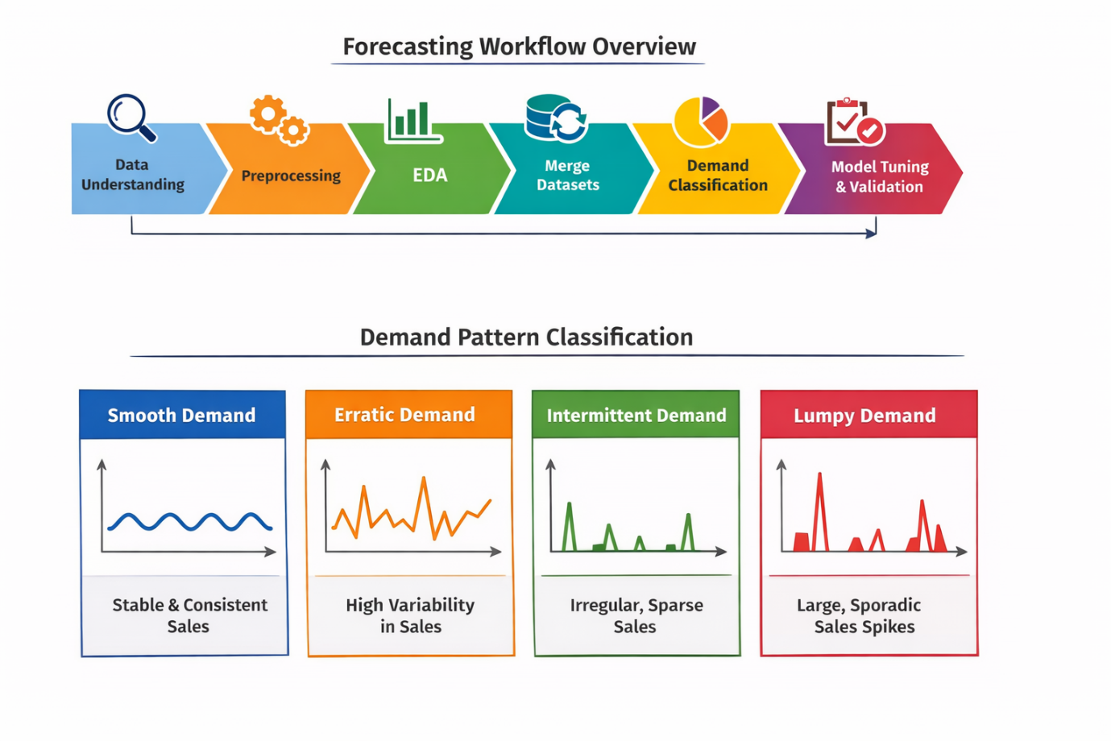

Future Progress:
The remaining work in the project will focus mainly on implementing the planned forecasting pipeline in a step-by-step manner and extending it into a complete forecasting system. The first major task in the next stage will be to execute the preprocessing and exploratory analysis process in detail. This includes cleaning both the Product Information and Weekly Sales datasets, analysing them separately, merging them properly, and then performing post-merge analysis to study sales behaviour across different business segments such as category, sub-category, and gender.
After this, the project will move into the demand classification phase, where each product will be assigned to one of the four demand classes: Smooth, Erratic, Intermittent, or Lumpy. This classification will help in understanding product demand behaviour more clearly and will also be useful in choosing suitable forecasting methods later. Additional analysis will also be done to understand how these demand classes are distributed across product groups and how much each class contributes to the total sales.
The next important stage will be internal feature engineering for forecasting. Features such as lag values, rolling averages, rolling variability, and time-based features will be created from the weekly sales data. Product-level attributes from the product information table will also be used as supporting inputs. Once the forecasting dataset is ready, multiple suitable forecasting models will be tested. Instead of selecting one model directly, the project will compare multiple candidate models and perform hyperparameter tuning to find the best-performing setup.
A major part of the future work will also involve time series cross-validation, which is important because normal random validation is not suitable for forecasting problems. This will help in evaluating models more realistically and selecting the best one based on performance. Once the internal-feature-based forecasting setup is completed, the project will then move into a more advanced stage by adding external features as exogenous inputs to check whether forecast accuracy can be improved further.
Towards the end of the semester, the project is also planned to include a chatbot or assistant layer that can answer forecast-related questions based on the final outputs. This will make the project more interactive and practical. If time permits, the final system may also be presented through a simple dashboard or application interface to make the results easier to explore and understand.

ANNEXURE:

Reading data
product_info = pd.read_excel(file_path, sheet_name='Product_Information')
weekly_sales = pd.read_excel(file_path, sheet_name='Weekly_Sales')

Basic summary
print(product_info.shape)
print(weekly_sales.shape)

Date conversion
weekly_sales_clean['Week_End_Date'] = pd.to_datetime(weekly_sales_clean['Week_End_Date'])

Declaration:
I hereby declare that the idea for this project is my original idea. The report is also original, and I give my consent to check this report for similarity and plagiarism.

